Ideas and objectives

- Define the terms ecosystem, community, trophic cascade
- Investigate how species interactions affect the dynamics of ecosystems
- Understand organisms can have both direct and indirect effects on other members of the ecosystem
- Indirect effects occur when an organism’s activity or behaviour affects other organism with which they do not directly interact - this is trophic cascade
- Trophic cascades can be found in diverse types of ecosystems

Read and watch more
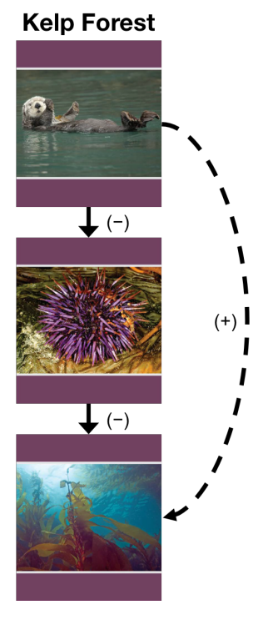
http://www.jyi.org/issue/a-review-of-management-problems-arising-from-reintroductions-of-large-carnivores/ - what are the problems with reintroduction of top carnivores

https://www.nps.gov/yell/learn/nature/wolves.htm - more info on Yellowstone national park

https://www.youtube.com/watch?v=M18HxXve3CM - how whales change climate

https://www.youtube.com/watch?v=LVJ5BKcAhAg - food webs

Trophic cascades occur when predators in a food web suppress the abundance or alter the behavior of their prey, thereby releasing the next lower trophic level from predation (or herbivory if the intermediate trophic level is a herbivore).

fill in the bubble diagram to show what happens to the populations of other species in the Yellowstone National Park when wolves were reintroduced in 1995

